**Title of the Experiment**

**EXCERSICE-6:**

Experiment 6

Consider the following schema for a Flight Database and draw an ER Diagram.

FLIGHT(Flight no: integer, Flight from: string, Flight to: string, distance: integer, departs: time, arrives: time, price: real)

AIRCRAFT (aid: integer, aname:string, cruisingrange:integer) CERTIFIED (eid:integer, aid:integer)

EMPLOYEES (eid:integer, ename:string, salary: integer)

Write SQL queries to

1. Find the names of aircraft such that all pilots certified to operate them have salaries more than Rs 80,000.

2. For each pilot who is certified for more than three aircrafts, find the eid and the maximum cruising range of the aircraft for which he/she is certified.

3. Find the names of all pilots whose salary is less than the price of the cheapest route from Bangalore to Frankfurt.

4. For all aircrafts with cruising range over 1000 kms, find the name of the aircraft and the average salary of all pilots certified for this aircraft.

5. Find the names of pilots certified for some Boeing aircraft. 6. Find the aid”s of all aircraft whose cruising range is greater than the minimum distancefrom the routes from Bangalore to Delhi

TABLE CREATION

mysql> CREATE TABLE flight (no INT (11), frm VARCHAR(20), too VARCHAR(20),

distance INT(11), departs VARCHAR (20), arrives VARCHAR(20), price double,

PRIMARY KEY (no) );

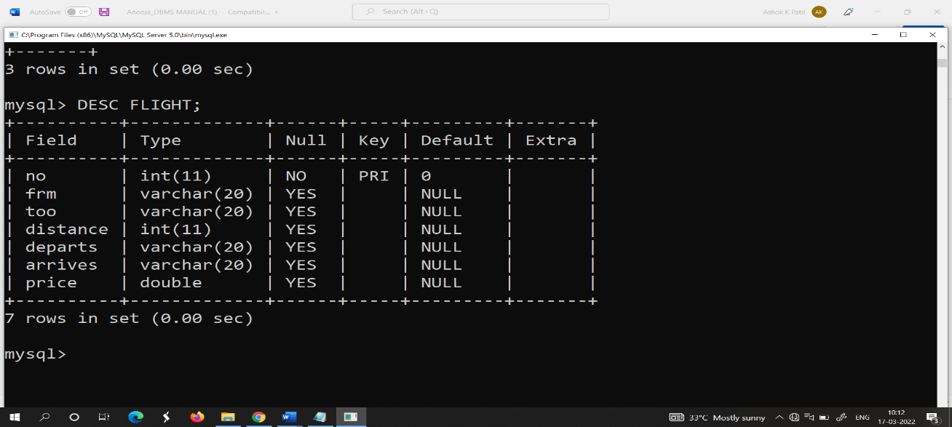

mysql> CREATE TABLE aircraft(aid INT, aname VARCHAR(20), cruisingrange INT,

PRIMARY KEY (aid) );

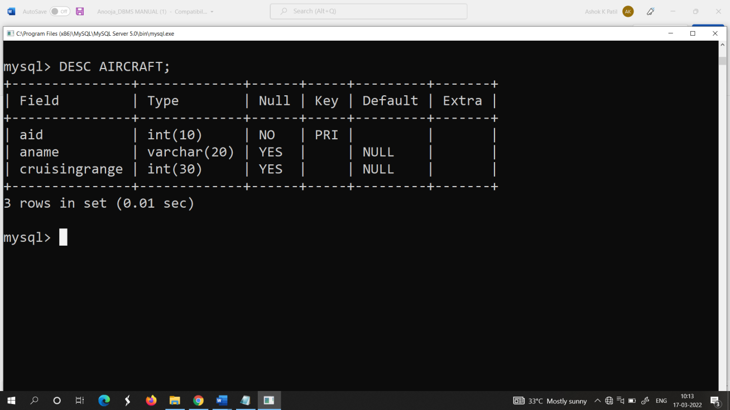

mysql> CREATE TABLE employees( eid INT(20), ename VARCHAR(20), salary INT (20), PRIMARY KEY (eid) );

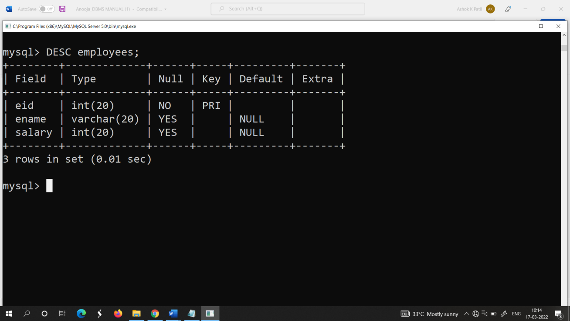



mysql> CREATE TABLE certified(eid INT(20), aid INT(10), PRIMARY KEY (eid,aid), FOREIGN KEY (eid) REFERENCES employees (eid),FOREIGN KEY (aid) REFERENCES

aircraft (aid) );

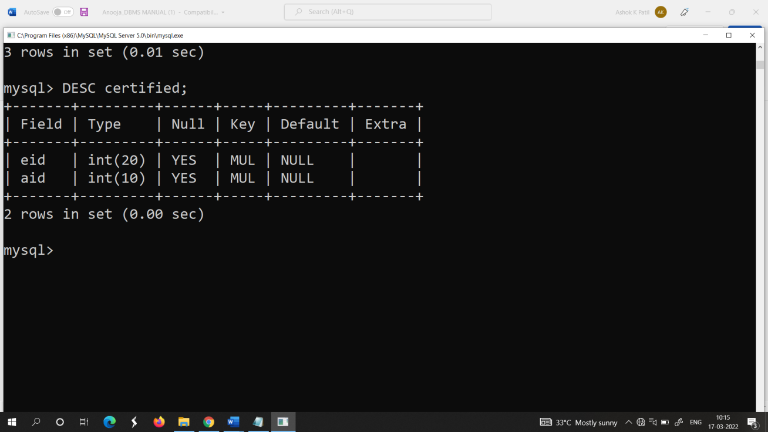

**INSERTION:**

**INSERT VALUES INTO FLIGHT TABLE:**

INSERT INTO FLIGHT VALUES (1, “BANGALORE”, “MANGALOINSERT VALRE”,360, “10:45:00”, “12:00:00”,10000);

INSERT INTO FLIGHT VALUES (2, “BANGALORE”, “DELHI”,5000, “12:15:00”, “04:30:00”,25000);

INSERT INTO FLIGHT VALUES (3, “BANGALORE”, “MUMBAI”,3500, “02:15:00”, “05:25:00”,30000);

INSERT INTO FLIGHT VALUES (4, “DELHI”, “MUMBAI”,4500, “10:15:00”, “12:05:00”,35000);

INSERT INTO FLIGHT VALUES (5, “DELHI”, “FRANKFURT”,18000, “07:15:00”, “05:30:00”,90000);

INSERT INTO FLIGHT VALUES (6, “BANGALORE”, “FRANFURT”,19500, “10:00:00”, “07:45:00”,95000);

INSERT INTO FLIGHT VALUES (7, “BANGALORE”, “FRANKURT”,17000, “12:00:00”, “06:30:00”,99000);

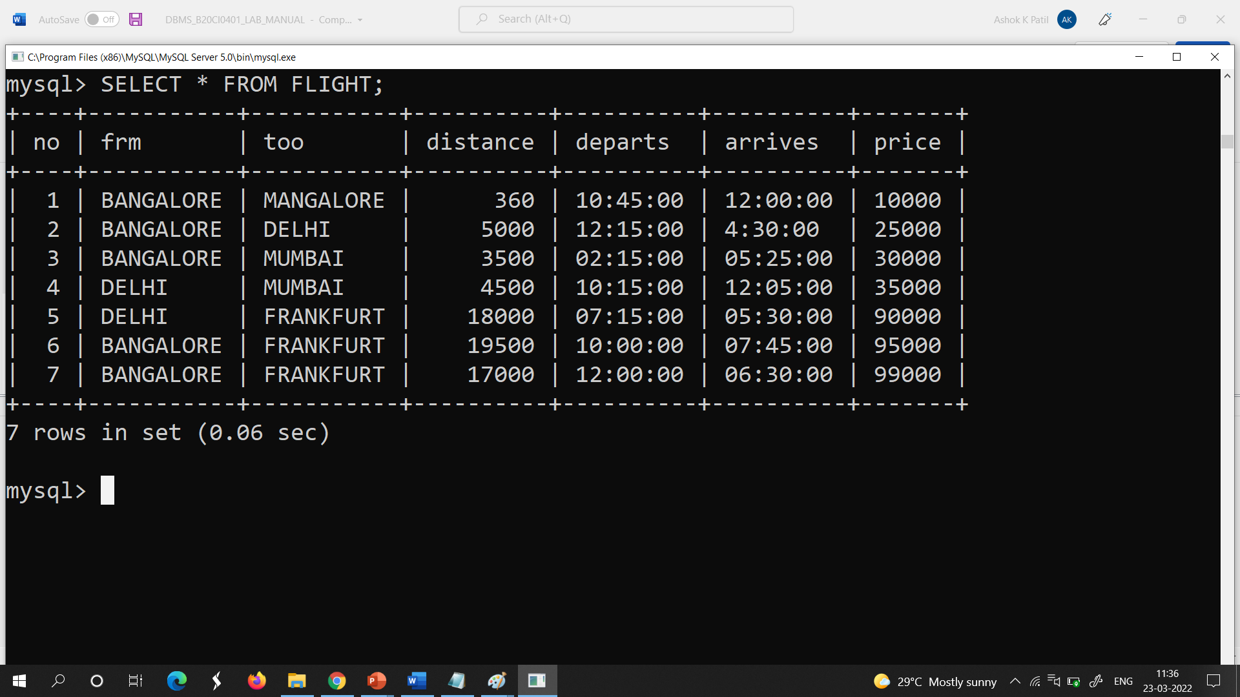

**INSERT VALUES INTO AIRCRAFT TABLE:**

INSERT INTO AIRCRAFT VALUES (123, “AIRBUS”,1000);

INSERT INTO AIRCRAFT VALUES (302, “BOEING”,5000);

INSERT INTO AIRCRAFT VALUES (306, “JET01”,5000);

INSERT INTO AIRCRAFT VALUES (378, “AIRBUS380”,8000);

INSERT INTO AIRCRAFT VALUES (456, “AIRCRAFT”,500);

INSERT INTO AIRCRAFT VALUES (789, “AIRCRAFT02”,800);

INSERT INTO AIRCRAFT VALUES (951, “AIRCRAFT03”,1000);

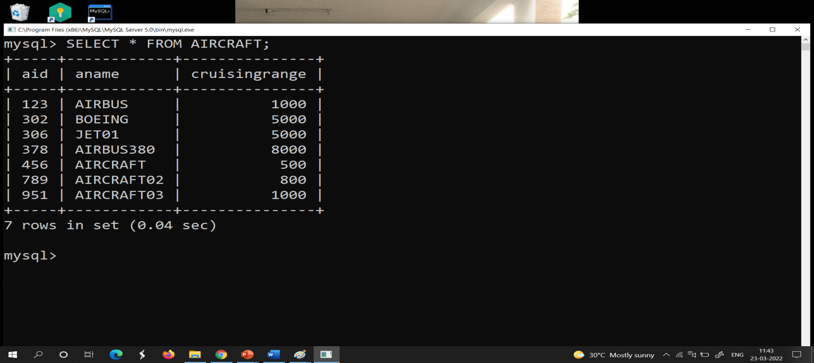

**INSERT VALUES INTO EMPLOYEE TABLE:**

INSERT INTO employees VALUES (1, “Ajay”,30000);

INSERT INTO employees VALUES (2, “Ajith”,85000);

INSERT INTO employees VALUES (3, “Arnab”,50000);

INSERT INTO employees VALUES(4, “Harry”,45000);

INSERT INTO employees VALUES(5, “Ron”,90000);

INSERT INTO employees VALUES (6, “Josh”,75000);

INSERT INTO employees VALUES (7, “Ram”,100000);

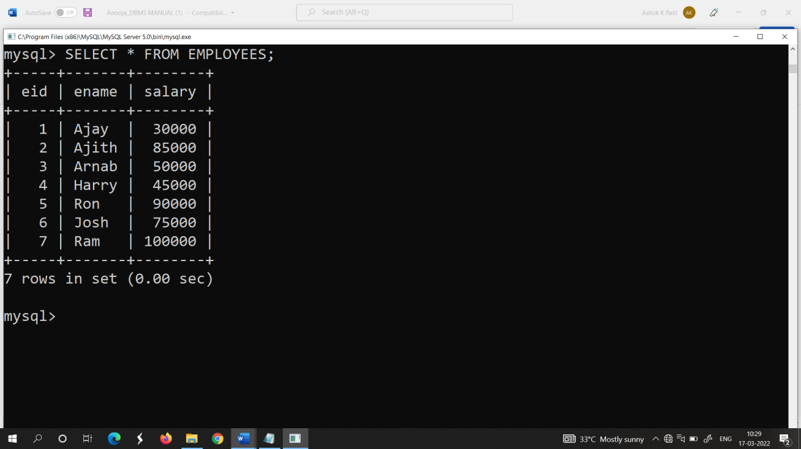

**INSERT VALUES INTO CERTIFIED TABLE:**

INSERT INTO certified VALUES (1,123);

INSERT INTO certified VALUES (2,123);

INSERT INTO certified VALUES (1,302);

INSERT INTO certified VALUES (5,302);

INSERT INTO certified VALUES (7,302);

INSERT INTO certified VALUES (1,306);

INSERT INTO certified VALUES (2,306);

INSERT INTO certified VALUES (1,378);

INSERT INTO certified VALUES (2,378);

INSERT INTO certified VALUES (4,378);

INSERT INTO certified VALUES (6,456);

INSERT INTO certified VALUES (3,456);

INSERT INTO certified VALUES (5,789);

INSERT INTO certified VALUES (6,789);

INSERT INTO certified VALUES (3,951);

INSERT INTO certified VALUES (1,951);

INSERT INTO certified VALUES (1,789);

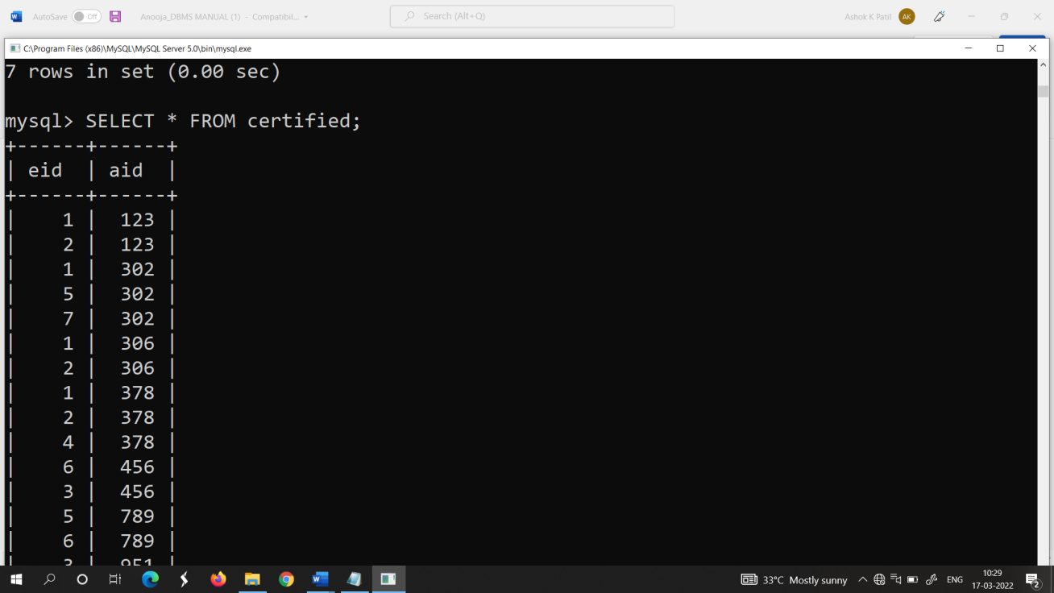

Queries:

1.Find the names of aircraft such that all pilots certified to operate them have salaries more than Rs 80,000.

SYNTAX:

SELECT DISTINCT a.aname FROM aircraft a,certified c,employees e WHERE a.aid=c.aid AND c.eid=e.eid AND EXISTS (SELECT * FROM employees e1 WHERE e1.eid=e.eid AND e1.salary>80000);

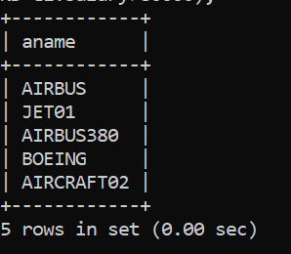

2.For each pilot who is certified for more than three aircrafts, find the eid and the maximum cruising range of the aircraft for which he/she is certified.

SYNTAX:

SELECT c.eid, MAX(cruisingrange) from certified c, aircraft a where c.aid = a.aid group by c.eid having count(*)>3;

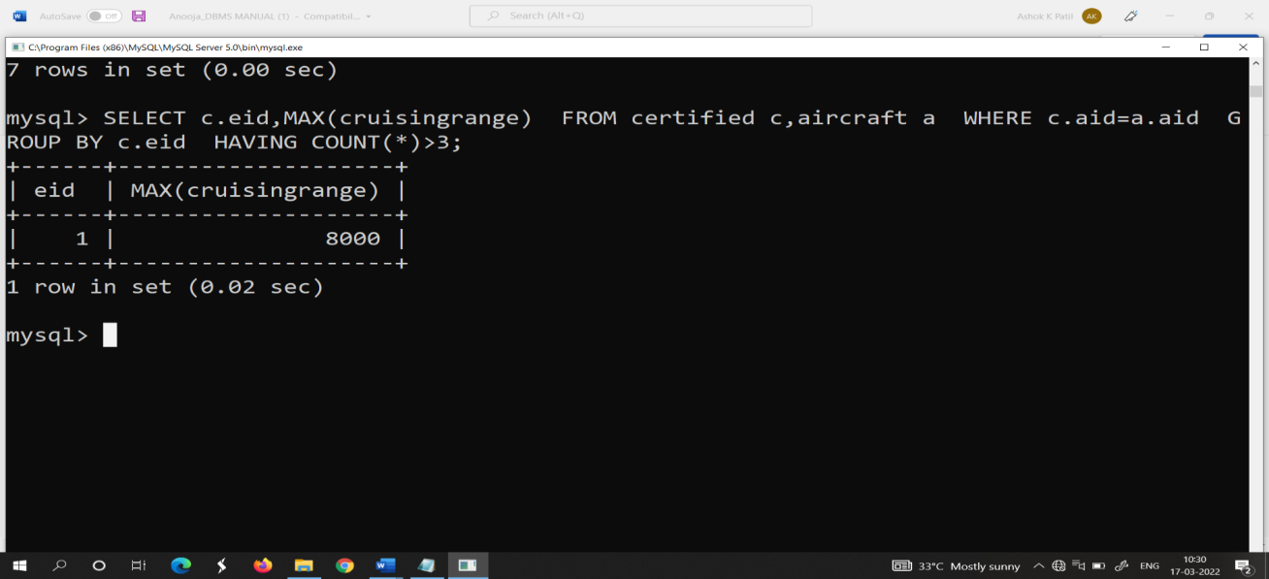



3.Find the names of all pilots whose salary is less than the price of the cheapest route from Bangalore to Frankfurt.

SYNTAX:

select ename from employees where salary < ( select min(price) from flight where frm = “bangalore” and too =“franfurt” );

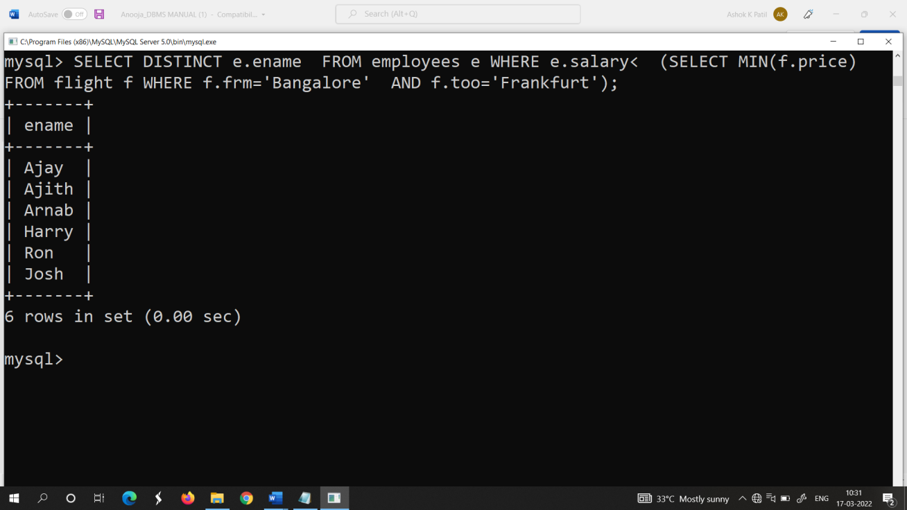

4.For all aircrafts with cruisingrange over 1000 kms,find the name of the aircraft and the average salary of all pilots certified for this aircraft.

SYNTAX:

Select a.aid, a.aname, AVG(e.salary) from aircraft a, certified c, employees e where a.aid = c.aid AND c.eid =e.eid AND a.cruisingrange > 1000 GROUP BY a.aid, a.aname;

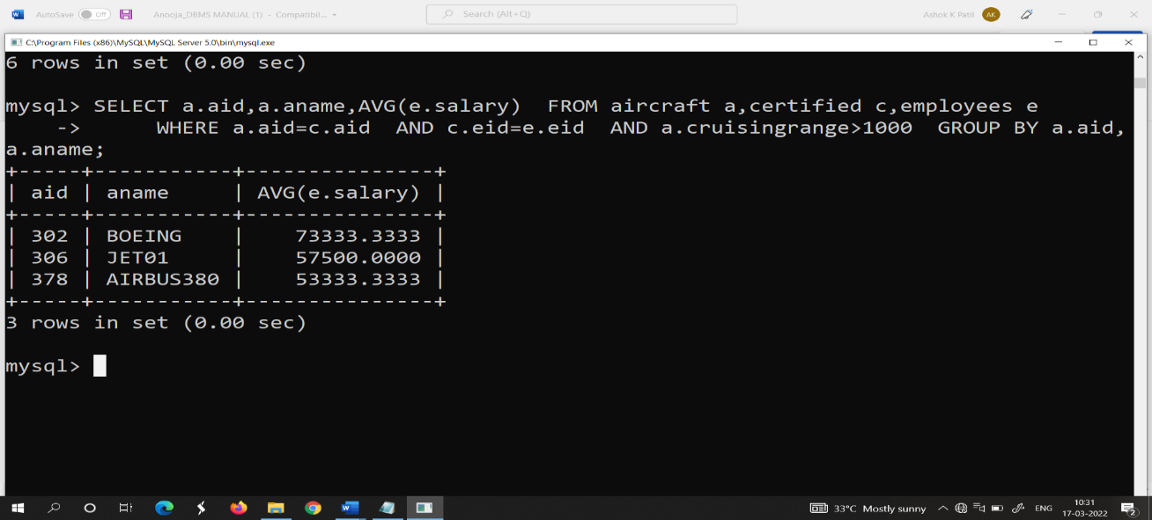

5.Find the names of pilots certified for some Boeing aircraft.

SYNTAX:

SELECT distinct e. ename from employees e, aircraft a, certified c where e.eid = c.eid AND

c.aid = a.aid AND a. aname = “Boeing”;

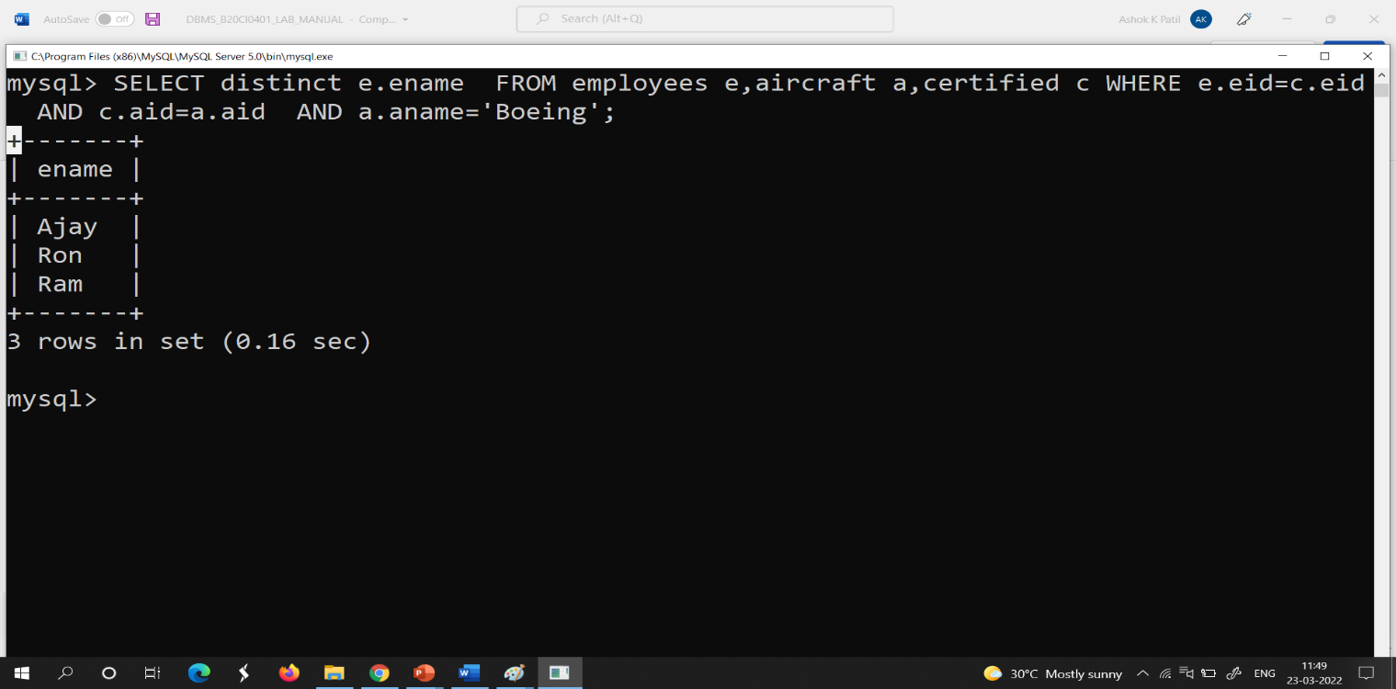

6.Find the aid”s of all aircraft whose crusing range is grater than the minimum distance from Bangalore to Delhi.

SYNTAX:

Select aid from aircraft where cruisingrange > (Select min(distance) from flight where frm= “Bangalore” and too= “Delhi”);

